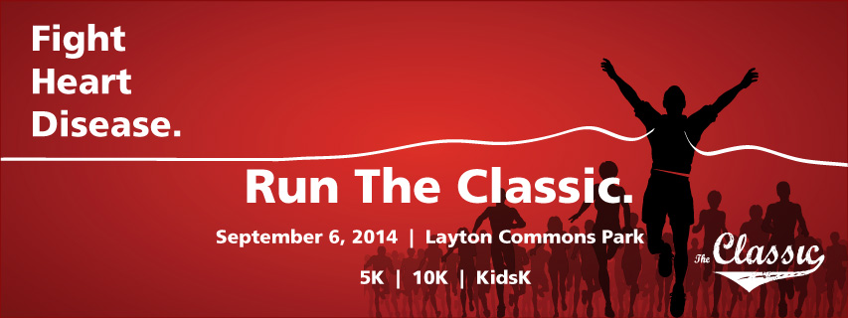

It’s that time of year again, time to lace up your shoes and join Intermountain McKay-Dee Hospital in the Fight Against Heart Disease at The Classic Race.

The Classic Race is one of Utah’s longest lasting traditions. What started as just a road race in 1984 has turned into an event where 100’s of runners join together year after year to help support heart services at McKay-Dee Hospital.

This year the event, featuring 10K, 5K, and KidsK events, will be on September 6, 2014 at Layton Commons Park. So come take part in this family friendly event and strengthen your own heart while you help fight heart disease!

Friends of Layton High School Cross Country Special Discount!
Get $10 off the registration price by using the discount code “LHSXC”. Now that is a deal you just can’t pass up!
Register now at:
https://registermyrace.com/register/the-layton-classic-10k-5k-kids-run/50

Prices Go Up on Sunday, August 17th
Regular registration ends at midnight on August 16th, so make sure you register in the next few days to take full advantage of the lowest registration cost possible. While your $5 off discount won’t end, regular registration fees will.
More Fun with Your Friends
Feel free to share the discount code with your friends and family and be the hero of the day!
See you September 6th!
For more information visit runtheclassic.org, get updates on Facebook at facebook.com/runtheclassic, or contact runtheclassic@gmail.com

